Docker 201 Project case study

We will be creating two tier Node application and will be containerizing the same.

Check whether git and docker are installed already.

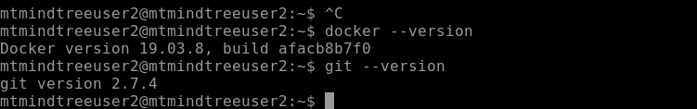

Now we will cloning 1 node js application code from internet.

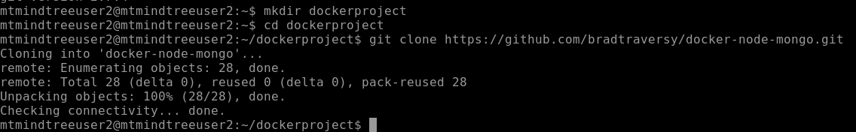

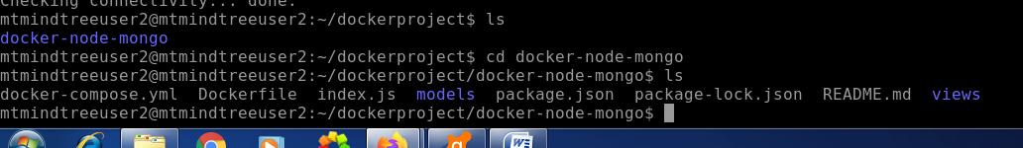

Try to execute some docker commands

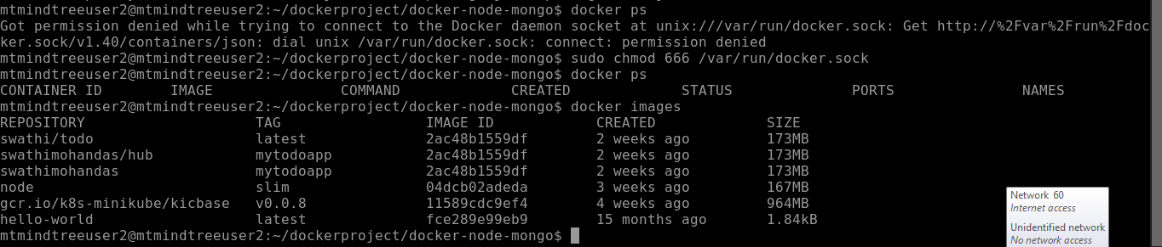

Now we will be creating the docker image for our application.

For that we need docker file.

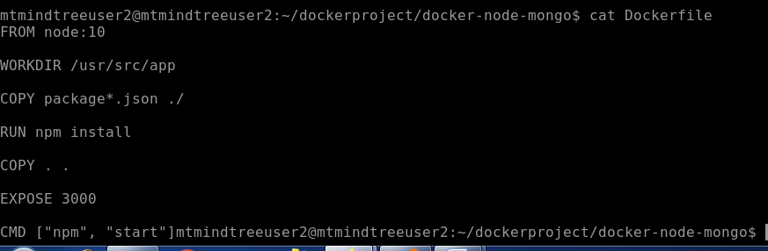

Now we will be executing the commands for building the image of the nodejs application

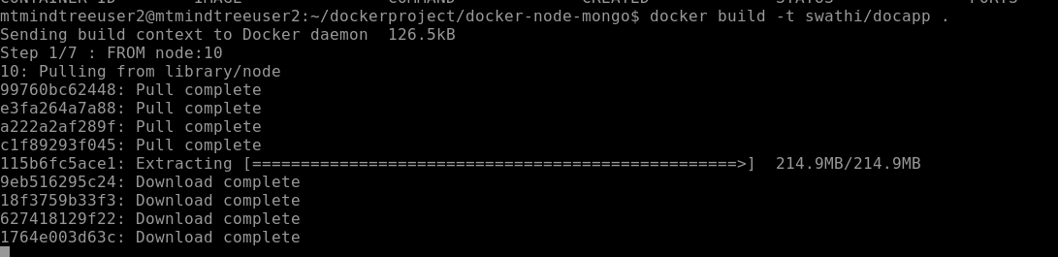

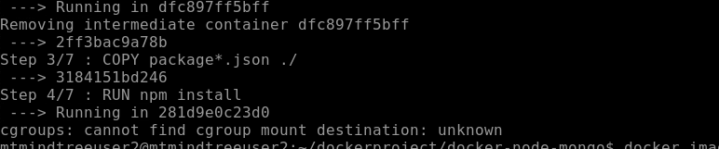

Received above error

To solve this,we executed below steps

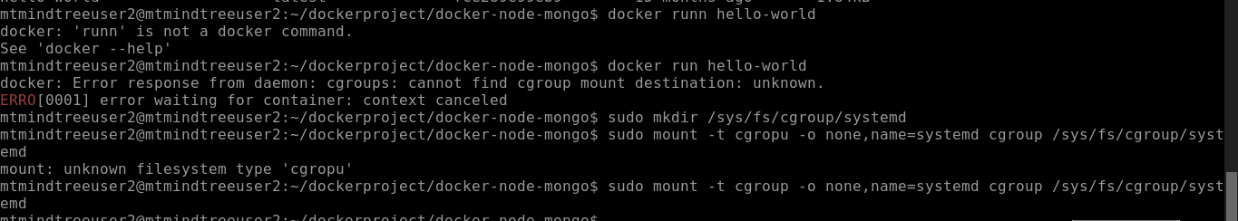

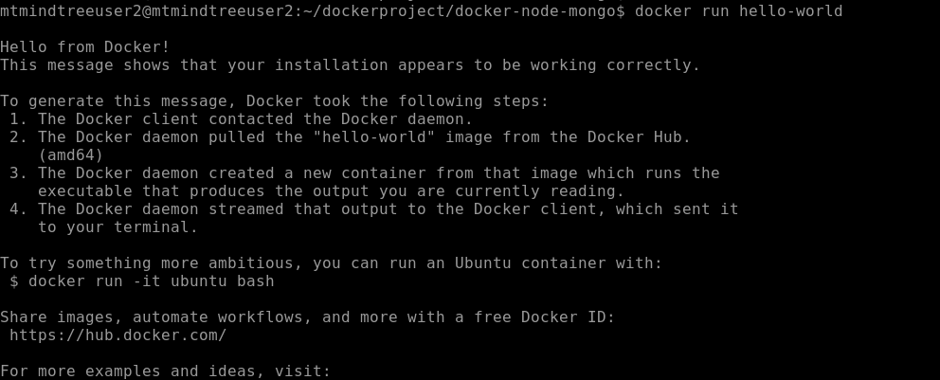

Now we will be building the image of the application again as follows.

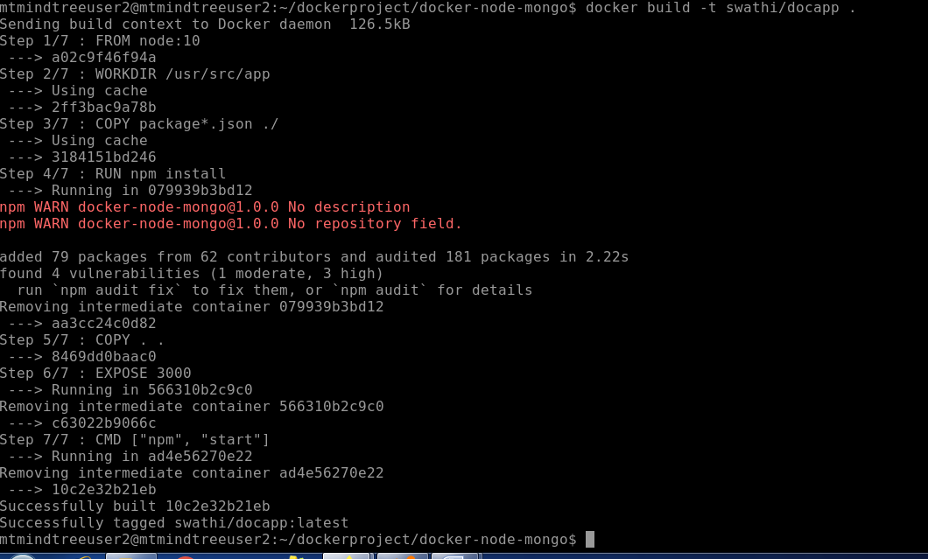

We could see the docker images created as follows

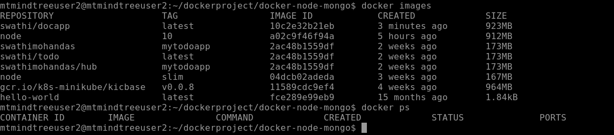

Now we will be running the node js application on port 8080 before that check whether there is any other applicaton running on the same port.



Now check the browser as well

